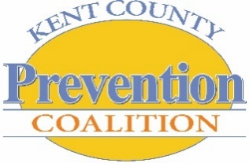
KENT COUNTY PREVENTION COALITION [KCPC]
General Assembly Meeting Agenda
January 23, 2018

Our mission: Building a healthier community by preventing and reducing harmful substance use behavior in Kent County with a major focus on youth.

WELCOME
- Thank you, network180 for hosting today’s meeting!
- Thank you Pine Rest for taking meeting minutes!
- Lunch provided by network180; Thank you!
- Welcome, Introductions, & General Housekeeping

ORDER OF BUSINESS ACTION/DECISION ITEMS
- Approval of January meeting agenda
- Approval of December meeting minutes – sent via monthly e-newsletter
- General Assembly Meeting Minutes:
*Mtg Minutes Due the 1st Thursday of the month*
February: network180
March: SeyferthPR

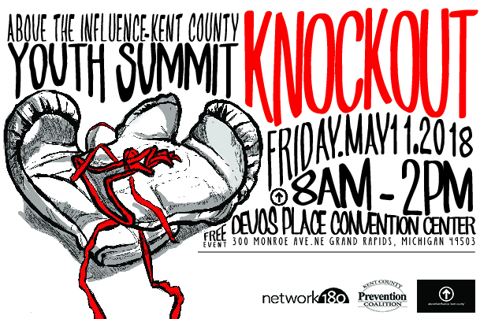
ACHIEVEMENTS & SUCCESSES!
Coalition Successes – We are an innovative coalition improving the health of our community by reducing the harmful use of alcohol, tobacco, and other drugs! Let’s celebrate the following coalition successes!

Abstract: SHOUT OUT to our 2018 KCPC ATI-Kent County ‘Knockout’ Youth Summit PLATINUM SPONSORS!
THANK YOU to Network180, Michigan HIDTA (High Intensity Drug Trafficking Areas), and Blue Cross Blue Shield of Michigan who represent this year’s Summit Platinum Sponsors!

Goal 5: Expand Coalition Capacity Through Partnerships
Educational: Marijuana Presentation – John Kroneck
Abstract: Michigan Prevention Association (MPA) members work in communities across Michigan to improve health and productivity and reduce harm caused by the addictive and early use of substances. Currently, the marijuana* industry is framing recreational drug use as medicinal use, discussing marijuana as a medical treatment of disease/injury, and claiming the use of marijuana to be a safer – even harmless – alternative to prescription drugs. The Michigan Prevention Association’s Medical Marihuana Task Force (MMTF) has reviewed the Michigan Medical Marihuana Law (MMML), held conferences, entered into dialog with other agencies and communities, and researched factors related to the implementation of the MMML. Today’s presentation will focus on the impact of Marijuana legalization in the State of Michigan and local communities.

KCPC Membership Confirmation! - Nadia Kimble
Abstract: Collaborative Involvement Agreements (CIA) are being distributed today to renew or join forces with the Kent County Prevention Coalition (KCPC). The success of the KCPC depends on the collaboration and mutual commitment of its partner members. To that end, the coalition has involved members that are continuously engaged in proving the ‘people power’ needed to carry-out the work of the coalition. Working together, all member stakeholders strive to transform our community by braiding funding streams, reducing the duplication of services and strengthening the community’s ability to address its issues. CIA packets are being distributed; our goal today is to renew our partnership and/or join forces with new community stakeholders. Please take time to complete the agreement and return via email, fax or mail prior to our next General Assembly meeting [February 27, 2018].

KCPC Committee Breakouts
Abstract: KCPC Committees are a small sub-set of GA members assigned to focus on a particular area and/or task. A committee will generally make recommendations to the Executive Committee or General Assembly. Regardless, any decisions made by such group remain the responsibility of the whole General Assembly. The landscape to engage, sustain, and mobilize the community around the issues of SUD (Substance Use Disorder) Prevention in Kent County will be led by the following KCPC Committees:
- Community Engagement- Expand the ATI movement beyond the Summit experience by expanding to schools, camps and other programs
- Data Committee - Better Drinking Culture – Collaboration with organizations with same goals
- ATI Youth Coalition – Youth Summit

Announcements, Articles…AND MORE! – Denise Herbert
- Public Health Concerns Regarding Marijuana
- Network180 Open Letter and Fact Sheet
- Youth Summit Poster Hanging Blitz

HAVE AN ANNOUNCEMENT? Send any applicable Successes, Announcements or Articles to kcpreventioncoalition@gmail.com

KCPC Calendar @ A Glance – SYNC UP!

SUMMIT 2018 DATES TO REMEMBER:
- January 31st – GA Poster Hanging Blitz!
- February 20th – Early Bird Registration Deadline – with incentive!
- March 13th – Youth Summit 2018 REGISTRATION DEADLINE
- April 6th – Volunteer/ Chaperone Registration DEADLINE
- April 24th – SUMMIT WORK DAY [12-1:30p] – ALL ARE WELCOME!
- May 10th – Volunteer Orientation/Walk-through – DeVos Place Convention Center, 5-6p
- May 11th – YOUTH SUMMIT 2018 [DeVos Place Convention Center, 8a-2p]

STAY CONNECTED to KCPC news & happenings via Facebook, Snapchat, Twitter, and the Instagram!

Next Gathering: Tuesday, February 27, 2018 @ Catholic Diocese of Grand Rapids [360 Division Ave. S. Grand Rapids, 49503]

]

Our mission: Building a healthier community by preventing and reducing harmful substance use behavior in Kent County with a major focus on youth.

