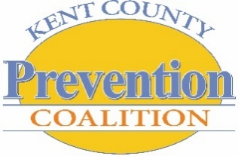
KENT COUNTY PREVENTION COALITION [KCPC]
General Assembly Meeting Agenda
December 20, 2016

Our mission: Building a healthier community by preventing and reducing harmful substance use behavior in Kent County with a major focus on youth.
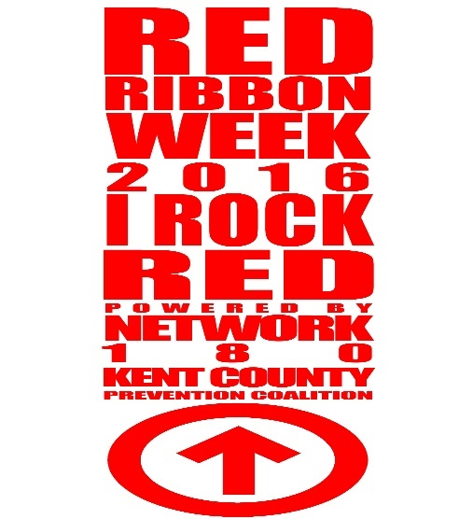

WELCOME
- Thank you, Wedgwood Christian Services for hosting this meeting!
- Thank you Com616 for taking meeting minutes!
- Lunch provided by Network180; Thank you!
- Welcome, Introductions, & General Housekeeping

ORDER OF BUSINESS ACTION/DECISION ITEMS
- Approval of December meeting agenda
- Approval of November meeting minutes
- General Assembly Meeting Minutes:
*Mtg Minutes Due the 1st Thursday of the month*
January: Community Family Partnership
February: Early Learning Neighborhood Collaboration

Coalition Successes – We are an innovative coalition improving the health of our community by reducing the harmful use of alcohol, tobacco, and other drugs! Let’s celebrate the following coalition successes!

ACHIEVEMENTS & SUCCESSES!
NEW KCPC Launches Updated Website With BIG Benefits!
Abstract: The KCPC logs another legacy moment! The new site can be found at www.kcpreventioncoalition.org and is 2 sites in 1. The updated Kent County Prevention Coalition website will serve as a hub for all things prevention and features the first one-stop resource site for youth in Kent County! BE SURE TO CHECK OUT the “Need Help” section of the site via: www.atikentcounty.org. We are so excited to offer such a “Tailor Made” resource to our community!
Goals 1-3: Behavioral Outcomes regarding alcohol and marijuana use
Student Leadership Report: Above the Influence-Kent County
Red Ribbon Week 2016
Abstract: Red Ribbon Week is a national underage substance use and violence prevention initiative celebrated annually the last week of October. Students and Staff from Godfrey Lee High School, City High School, Innovation Central High School and Union High School will share an update on the impact of ATI Week and Red Ribbon Week-Above the Influence Kent County 2016 Activities. Students from each partner schools will provide a full debrief of efforts targeting nearly 4,000 Kent County teens in partnership with the KCPC and Network180!

Above the Influence-Kent County Youth Summit 2017
Abstract: An update on Summit 2017 Planning will be shared.

SUMMIT 2017: BACK TO BASICS!

- Summit Save-The-Date – HOT OFF THE PRESSES!!!
- Meet the 2016-2017 KCPC Youth Coalition DREAM TEAM
- Summit Executive Summary – Read and Share!
  - Summit Theme
  - Logistics
  - Coming Soon: OPEN REGISTRATION, SPONSORSHIP, and VOLUNTEERS
  - Q & A

SUMMIT 2017 DATES TO REMEMBER:
- January 3rd – Youth Summit 2017 REGISTRATION OPENS
- March 3rd – Early Bird Registration Deadline – with incentive!
- March 24th – Youth Summit 2017 REGISTRATION DEADLINE
- April 7th – Volunteer/ Chaperone Registration DEADLINE
- April 25th – SUMMIT WORK DAY [12-1:30p] – ALL ARE WELCOME!
- May 11th – Volunteer Orientation/Walk-through – DeVos Place Convention Center, 5-6p
- May 12th – YOUTH SUMMIT 2017 [DeVos Place Convention Center, 8a-2p]

Announcements, Articles…AND MORE!
- National Drug & Alcohol Week Announcement Summary
- MIP (Minor in Possession) Law – Senate Bill 0332
- E-Cigarette Surgeon General Report https://e-cigarettes.surgeongeneral.gov/documents/2016_SGR_Full_Report_non-508.pdf

HAVE AN ANNOUNCEMENT? Send any applicable Successes, Announcements or Articles to kcpreventioncoalition@gmail.com

KCPC Calendar @ A Glance – SYNC UP!

2017:
- January 3rd Youth Summit 2017 REGISTRATION OPENS! – Additional Summit Dates noted above
- January 23-29 National Drug & Alcohol Week
- February 28th KCPC Lunch & Learn: ‘Leadership & Emotional Wellness Part 1’ – in place of monthly GA Mtg.
- March 28th KCPC Lunch & Learn: ‘Leadership & Emotional Wellness Part 2’ – in place of monthly GA Mtg.
- May 12th YOUTH SUMMIT 2017!!!

STAY CONNECTED to KCPC news & happenings via Facebook, YouTube, Twitter, Flickr and the Instagram!

HAPPY HOLIDAYS!
Next GA Meeting: Tuesday, January 24, 2017 @ Network 180 790 Fuller Ave NE 49503

